HOMEWORK #1
Statistics 10 | William Anderson, TA

#1.1

Study #1

The condition applied (treatment) to the unit is the body weight, and the response to the treatment is the level of intelligence. This study is an observational study, because there was not a deliberate treatment applied to the units. The researcher cannot control an individual’s body weight. Hence, this study cannot be done as an experiment because it would require the experimenter to control the weight of the subjects. Blocking was not used in this study.

Study #2

The treatment in this study is the different baking temperatures, and the response is the impact strength of the material. This study is an experiment, because the researcher deliberately imposed some treatment on the units in order to observe their responses, in other words he could decide which treatment could be applied to the unit. Blinding could be used during the testing phase of the study, where the tester would not know the temperature at which the individual boards were baked. Blocking was not used in this study. Blocking could have been used, by separating the boards by their dimensions (length, width, thickness, etc.)

Study #3

The treatment in this study is the diagnostic machine, and the response is the time it takes to complete a regular service. This study is an experiment, because the researcher deliberately imposed some treatment on the units in order to observe their responses. This is a very poor experiment. In this study, there are confounding variables that are not controlled (e.g. the “learning effect”-the repeated performing of a task.) The experiment could significantly improved by introducing randomization. A possible form of blinding could be that the mechanic is not told about the experiment, so they will not introduce personal biasness for or against the new diagnostic tool. The blocking that was used in the experiment was the mechanics experience. Blocking was implimented used in this study to see if the mechanics experience plays a role in the time to complete a regular service.

Study #4

The treatment in this study is the examination on 10 different subjects, and the response is the letter grades A, B, C, and D. This study is observational in nature, because the researcher did not impose any treatment. An experiment could not be performed, because the researcher cannot control an individual’s gender. Blocking was not used in this experiment.
#1.2

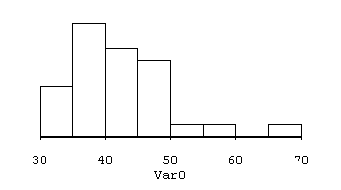
The stem-and-leaf plot should have the same shape as the above histogram. On the stem-and-leaf plots, the stems should have been split into 30-34, 35-39, 40 44, 45-49 etc. In other words, 8 bins should be used in the stem-and-leaf plot.

Minimum | Q1 | Median | Q3 | Maximum
32 | 37.5 | 41 | 47 | 68

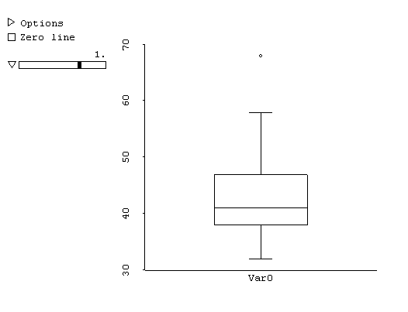
The distribution is unimodal and skewed right. The observation of 68 is possibly an outlier. The fact that Q3 lies farther above the median than Q1 lies below indicates the right skewness of the data. This can also be seen in the histogram above.

