Stat 221 midterm, Prof. Rick Schoenberg, 11/7/22, 9:30-10:45am.

**Bring a calculator.**

You may need to know that ∑x^k = 1/(1-x), for x between 0 and 1, where the sum is from k = 0 to ∞.

You can use any notes or books. Either pen or pencil is fine.

You cannot use anything that can surf the net, like a laptop, phone, or ipad.

Example problems.

**1. Suppose Xt = 3Xt-1 - 2Xt-2 - Wt-1 + Wt , where W is white noise.**

**a. Is the model in reduced form? If not, what is the reduced model?**

**b. Is it causal?**

**c. Is it invertible?**

a. The AR polynomial is φ(z) = 1 - 3z + 2z^2 = (2z-1)(z-1), which has roots z=1/2 and z=1.

Alternatively, the roots are [-b +/- √(b^2-4ac)]/2a, where a = 2, b = -3, c = 1, so the roots are [3 +/- √(9-8)]/4 = 3/4 +- 1/4, or 1/2 and 1.

The MA polynomial is = θ(z) = (1-z), which has root 1. (1-z) is in common. Not reduced.

Reduced model has AR polynomial φ(z) = -(2z-1) = 1-2z. Reduced MA polynomial is θ(z) = 1. So the reduced model is Xt = 2Xt-1 + Wt .

b. The reduced model has AR polynomial 1-2z, with root 1/2. 1/2 is inside the unit circle, | 1/2 | ≤ 1, so the model is not causal.

c. The MA polynomial is 1, which has no roots. So it is invertible. There are no roots on or inside the unit circle.

**2. Consider the causal MA(1) model Xt = 0.7 Wt-1 + Wt , where W is white noise with variance 20. Let (h) be the autocovariance function of Xt.**

**a. What is (0)?**

**b. What is (1)?**

a. (0) = cov(Xt , Xt) = cov(0.7 Wt-1 + Wt, .0.7 Wt-1 + Wt)

= .49 cov(Wt-1 , Wt-1) + 0 + 0 + cov(Wt , Wt)

= .49 (20) + 20

= 29.8.

Alternatively,

V(Xt) = V(0.7 Wt-1 + Wt)

= .72 V(Wt-1) + V(Wt) + 2cov(0.7 Wt-1 , Wt)

= .49 (20) + 20 + 0.

b. (1) = cov(Xt , Xt-1) = cov(0.7 Wt-1 + Wt, 0.7 Wt-2 + Wt-1)

= 0 + .7 cov(Wt-1 , Wt-1) + 0 + 0

= .7 (20)

= 14.0.

Here Xt is already expressed as a pure MA so the -weights are obvious.

Note that φ  = θ, so (1) (1 + 1z + 2z2 + ...) = 1 + 0.7z.

Match the different powers of z, starting with 0.

1 = 1.

1z = 0.7z. So 1 = 0.7.

2z2 = 0. So 2 = 0. Similarly 3 = 0, etc.

Xt = Wt + 1 Wt-1 + 2 Wt-2 + ....

= Wt + 0.7 Wt-1 .

**3. Consider the causal, invertible, reduced ARMA(2,2) process**

**Xt = 0.3 Xt-1 + 0.1 Xt-2 + 0.2 Wt-2 + 0.4 Wt-1 + Wt , where W is white noise with variance 20. Let (h) be the autocovariance function of Xt.**

**a. Find the first 4 -weights: 1, 2, 3, and 4.**

**b. Use these first 4 -weights to approximate (0).**

**c. Use these first 4 -weights to approximate (1).**

a. φ  = θ,

so (1-.3z-.1z2) (1 + 1z + 2z2 + ...) = 1 + 0.4z + 0.2 z2 .

Be careful here! 0.4 goes with z and 0.2 goes with z2 .

Match the different powers of z, starting with 0.

1 = 1.

-.3 + 1 = .4. 1 = .7.

-.1 - .31 + 2 = 0.2. So 2 = 0.2 + .1 + .3(.7) = .51.

3 - .32 - .11 = 0. So 3 = .1(.7) + .3(.51) = .07 + .153 = .223.

4 - .33 - .12 = 0. So 4 = .1(.51) + .3(.223) = .1179.

b. Xt ~ Wt + .7 Wt-1 + .51 Wt-2 + .223 Wt-3 + .1179 Wt-4 .

V(Xt) ~ 20 + .72 (20) + .512 (20) + .2232 (20) + .11792 (20)

= 20 (1 + .49 + .2601 + .049729 + .01390041)

= 20 (1.813729)

= 36.27458.

c. cov(Xt, Xt-1) ~ cov(Wt + .7 Wt-1 + .51 Wt-2 + .223 Wt-3 + .1179 Wt-4 ,

Wt-1 + .7 Wt-2 + .51 Wt-3 + .223 Wt-4 + .1179 Wt-5)

= 0 + .7 (20) + (.51)(.7) (20) + (.223)(.51)(20) + (.1179)(.223)(20)

= 23.94043.

Cov(X_t, X_{t-3}) = cov(Wt + .7 Wt-1 + .51 Wt-2 + .223 Wt-3 + .1179 Wt-4 ,

Wt-3 + .7 Wt-4 + .51 Wt-5 + .223 Wt-6 + .1179 Wt-7 )

= (.223)(1)(20) + (.1179)(.7)(20).

(1) = Cov(0.3 Xt-1 + 0.1 Xt-2 + 0.2 Wt-2 + 0.4 Wt-1 + Wt ,

0.3 Xt-2 + 0.1 Xt-3 + 0.2 Wt-3 + 0.4 Wt-2 + Wt-1)

= 0.3^2 (1) + (.1)(.3) var(Xt-2) + …. (complicated…)

Cov(Xt , Wt ) = Cov (0.3 Xt-1 + 0.1 Xt-2 + 0.2 Wt-2 + 0.4 Wt-1 + Wt, Wt)

= cov(Wt, Wt) = 20.

**4. Suppose the correlogram below corresponds to a time series of 200 observations. What model might be consistent with this correlogram?**

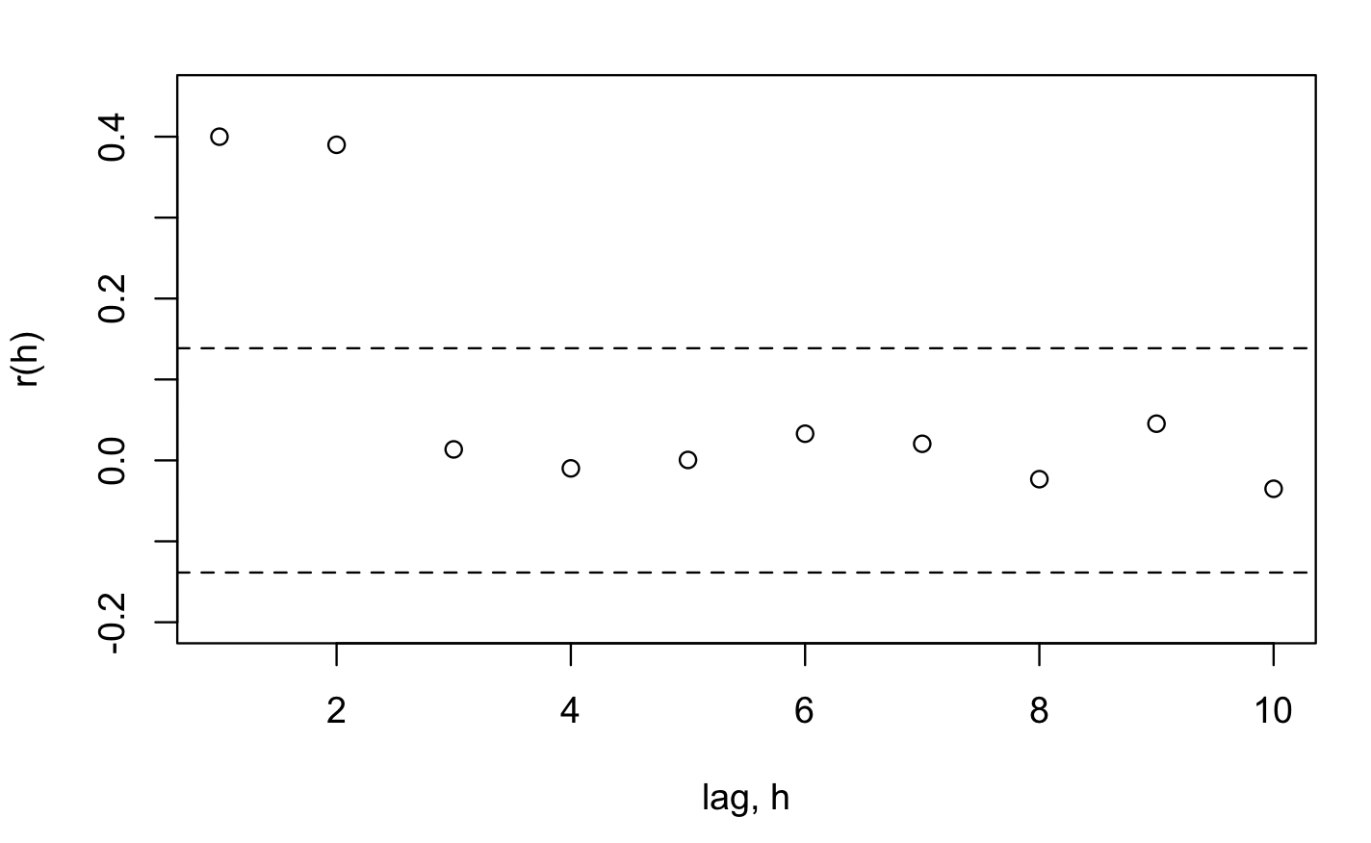

MA(2).