Bootstrap Method
> # Purpose: understand how bootstrap method works
> obs=c(11.96, 5.03, 67.40, 16.07, 31.50, 7.73, 11.10, 22.38)
> n=length(obs)
> mean(obs)
[1] 21.64625
> # estimate of lambda
> lambda = 1/mean(obs); lambda
[1] 0.04619738
> # The exponential distribution with rate=lambda has density f(x) = lambda e^(- lambda x)
> # draw a random sample of size n from exponential(lambda) distribution, where lambda is estimated from data
> x=rexp(n, lambda); x
[1] 4.451616 12.097513 6.302449 21.942872 37.191007 76.530816 9.458349 11.386464
> mean(x)
[1] 22.42014
> 1/mean(x) # Bootstrap estimate of lambda
[1] 0.04460276
> # do it again
> x=rexp(n, lambda); x
[1] 9.4759699 2.5089895 0.1630891 0.7994896 51.2508151 10.9096888 9.2945093 2.8122216
> mean(x)
[1] 10.90185
> 1/mean(x) # Bootstrap estimate of lambda
[1] 0.09172758
> # here we do a nonparametrical bootstrape by replacing x=rexp(n, lambda) with x=sample(obs, n, replace=T)
> x=sample(obs, n, replace=T); x
[1] 11.10 22.38 67.40 31.50 5.03 7.73 11.10 22.38
> mean(x)
[1] 22.3275
> 1/mean(x) # Bootstrap estimate of lambda
[1] 0.04478782
> # do it again
> x=sample(obs, n, replace=T); x
[1] 5.03 11.10 11.96 16.07 11.96 31.50 16.07 11.96
> mean(x)
[1] 14.45625
> 1/mean(x) # Bootstrap estimate of lambda
[1] 0.06917423
> # repeat the procedure B times, save the B sample means in xbar and sample sd in ss[]
> B=200; xbar = rep(0, B); ss = rep(0, B)
> for(i in 1:B) { x=sample(obs, n, replace=T); xbar[i] = mean(x) }
> # the B bootstrap estimate of lambda are
> lambda.bt = 1/xbar
> summary(lambda.bt)
Min. 1st Qu. Median Mean 3rd Qu. Max.
0.02127 0.04039 0.04856 0.05142 0.05994 0.09881
> # bootstrap estimate of standard error
> sd(lambda.bt)
[1] 0.01565485
> # distribution of the bootstrap estimates
> stem(lambda.bt)

The decimal point is 2 digit(s) to the left of the |

2 | 1
2 | 55789
3 | 00112222333344444444
3 | 55556666777888889999
4 | 00000011111112222222233344444
4 | 5555666666677778888888889999999
5 | 00011112222233333333444444444
5 | 6666667888889
6 | 0000001222334
6 | 566677789
7 | 0000011222334
7 | 57
8 | 01124
8 | 56667
9 | 034
9 | 89

> hist(lambda.bt)
> lambda.bt.sub = lambda.bt-mean(lambda.bt)
> hist(lambda.bt.sub)
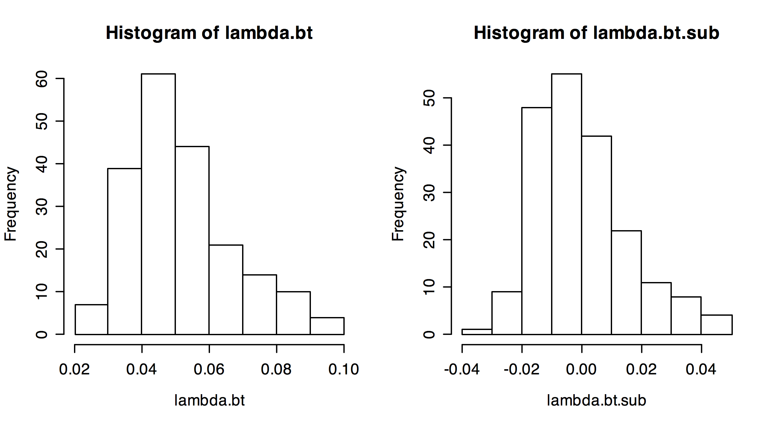
> # 5 and 95 percentiles of lambda.bt-mean(lambda.bt)
> quantile(lambda.bt.sub, c(.05, .95) )
5% 95%
-0.01940520 0.03217117
> # 90% bootstrap CI
> c(lambda-quantile(lambda.bt.sub,.95), lambda-quantile(lambda.bt.sub,.05) )
95% 5%
0.01402620 0.06560257

